CA1: Requirements and Domain Analysis Dossier
Object-Oriented Analysis and Design (OOAD)

Tsubasa Hirose
T00309367

Repository URL: https://github.com/TsubasaHMTU/ca1-analysis

Table of Contents
1 Executive Summary 4
2 Scenario Interpretation 4
2.1 Organisation and Present Process 4
2.2 Identified Problems and Consequences 5
2.3 Desired Outcomes 5
2.4 Evidence vs. Uncertainty Register 6
3 Purpose, Scope, and Boundary 6
3.1 System Purpose 6
3.2 In-Scope and Out of Scope 6
3.3 Dependencies, Assumptions, and Constraints 7
4 Stakeholder and Actor Catalogue 7
4.1 Stakeholder Catalogue 7
4.2 Actor-Goal Analysis 7
5 Requirements Catalogue 7
6 Business Rules and Uncertainty Register 7
6.1 Business Rules 7
6.2 Clarification Questions 8
7 Use-Case Model and Behavioral Scenarios 9
7.1 Use-Case Overview 9
7.2 Detailed Use-Case Specification 10
7.3 Behavioral Scenarios (Gherkin References) 12
8 Candidate Concepts and Domain Vocabulary 12
8.1 Concept Extraction and Decisions 12
8.2 Domain Glossary 12
9 Conceptual Domain Model 13
9.1 Conceptual Domain Model Diagram 13
9.2 Modelling Rationale 13
10 Traceability Matrix 14
11 Reflection and AI Declaration 14
References 15
Appendix 15
User stories 15

Executive Summary
The Tralee office supports internal banking services used by teams in several locations. It coordinates planned service changes, investigates operational incidents, and communicates service status to authorised internal users. In that work, fragmented channels make it inefficient to compare several records, and differing meanings of criticality, impact, and priority between teams make it hard to establish an appropriate operational plan.
This dossier presents a requirements and domain analysis of this problem. It does not describe a software implementation.
This analysis therefore aims at a system that aligns the definitions of criticality and priority so that requests and approvals are repeatable, manages the sequence from request and approval through implementation, review, and closure as one recorded process, and makes the required evidence visible under the correct access control.
The scope is operational change and incident coordination for internal banking services. Customer account processing, financial trading, transaction authorisation, fraud decisions, and detailed cybersecurity operations are out of scope.
The scenario was first organised into business requirements. For the use case of approving a change request, a detailed specification and behavioural scenarios were produced. A domain model was also created to show the relationships among the main concepts. Some scenario uncertainties were recorded as assumptions, and others were left in the uncertainty register.

Scenario Interpretation

Organisation and Present Process
Atlantic International Banking Services is an international banking group with an office in Tralee. That office holds the functions that support the internal banking business in the region. It does not provide services directly to individual customers. Working with business owners and operational support teams, the office develops and operates functions such as payments processing, account reporting, reconciliation, market-data distribution, and regulatory reporting.
Staff use several communication channels. To establish the latest status of requests, approvals, updates, and the other steps in a service plan, they compare several records, including email and spreadsheets.

Identified Problems and Consequences
 | Identified problems | Consequences
P01 | Channels are fragmented. | Staff must check several records, which is inefficient.
P02 | The meaning of service criticality, change impact, and incident priority differs between teams. | An appropriate operational plan cannot be established.
P03 | The approval process is not optimised for the operation. | Even when a change is approved individually, a resource conflict can make it necessary to postpone the plan.
P04 | The way an urgent change proceeds, and the way it is approved, have not been defined. | An urgent change may create a further risk.
P05 | The definition of completion differs between stakeholders. | A review may remain unfinished and never be closed.

Desired Outcomes
To realise this system, the definitions and conditions for service criticality and incident priority must be established, so that a request or an approval remains repeatable whichever user carries it out.
The system must also manage the whole sequence, from service planning and approval through implementation of the change, review, and closure, so that the sequence can be completed inside the system. The required evidence and information must be visible in the system under the correct access control.

Evidence vs. Uncertainty Register
Known evidence
- Channels are fragmented.
- A normal change requires individual assessment and approval.
Uncertainty register
- Who decides that a change is urgent.
- What information each role may access.

Purpose, Scope, and Boundary

System Purpose
The purpose of the system is to coordinate operational service changes and incidents for the Tralee office as one recorded sequence, from the change request and approval through implementation, review, and closure. Authorized staff can determine the current approved plan, the implementation outcome, and the status of a related incident, within the access allowed for their role.

In-Scope and Out of Scope
The system covers operational change and incident coordination for internal banking services. In scope are submitting a service-change request, assigning approvers, approving or rejecting a normal change, checking for conflicting work, recording the implementation outcome, keeping the change and review record, and recording an incident report while the incident is in progress.
Deciding the priority between conflicting changes is outside the scope. Customer account processing, financial trading, transaction authorisation, fraud decisions, and detailed cybersecurity operations are also outside the scope. Operational coordination records do not include detailed account data, transaction values, or security configuration.

Dependencies, Assumptions, and Constraints
This analysis treats “Technical lead” and “technical owner” as one role, and “Operations analyst” and “operational support” as one role. The scenario uses both names in each pair and does not confirm that they are the same role.
The assigned approver has an active account. The scenario does not state how staff authenticate or which accounts are valid.

Stakeholder and Actor Catalogue

Stakeholder Catalogue
https://github.com/TsubasaHMTU/ca1-analysis/blob/main/ca1-analysis/requirements/stakeholder-catalogue.docx

Actor-Goal Analysis
https://github.com/TsubasaHMTU/ca1-analysis/blob/main/ca1-analysis/requirements/actor-goal-table.docx

Requirements Catalogue
https://github.com/TsubasaHMTU/ca1-analysis/blob/main/ca1-analysis/requirements/requirements-catalogue.docx

Business Rules and Uncertainty Register

Business Rules
ID | Rule | Changeability | Source
RULE1 | A change is classified as exactly one of standard, normal, or urgent. | Low. The scenario presents these three categories as the classification in use. | Planned change requests: a change can be standard, normal, or urgent.
RULE2 | An implementation outcome is one of successful, successful with follow-up, rolled back, partially completed, or failed. | Low. The scenario gives this set of results. | Scheduling, dependencies and implementation: the result may be successful, successful with follow-up, rolled back, partially completed, or failed.
RULE3 | Operational coordination records do not include detailed account data, transaction values, or security configuration. | Low. The scenario treats this information as restricted. | Banking services and operational ownership: detailed account data, transaction values, and security configuration are restricted. Customer account processing and detailed cybersecurity operations are outside scope.
RULE4 | Each service has a business owner, an operational support team, and one or more technical components. | Low. The scenario states this structure as the way services are organised. | Banking services and operational ownership: each service has a business owner, an operational support team, and one or more technical components.

Clarification Questions
ID | Question | Why it matters
Q1 | Which approvals are required for each service, change type, and time period? | The answer changes the required approvers, the information that must be recorded, and the approval flow.
Q2 | How should conflicting changes and shared technical dependencies be related to existing change requests? | Without that relationship, approved changes cannot be compared.
Q3 | Who decides that a change is urgent, and when? | The request and approval flow changes if the requester decides this when submitting the request, or if an approver decides it while evaluating a normal change.
Q4 | Which operational, technical, business, and review information may each internal role access? | The answer changes the information included in each role's requirements and use cases.
Q5 | Who decides whether a change to the plan is material and requires reassessment? | The approval flow changes if the system decides, if the requester decides, or if an approver decides.

Use-Case Model and Behavioral Scenarios
The Banking Operations Change and Incident Service is used mainly by four actors: Team, Assigned approver, Change coordinator, and Internal service user. The six use cases listed below are treated as actor goals. UC03 is described in detail in section 7.2, and the behavioral examples are in section 7.3.

Use-Case Overview
ID | Use case | Primary actor | Related  requirements
UC01 | Submit a service-change request | Team | FR01
UC02 | Assign approvers and request approval | Team | FR02
UC03 | Approve or reject a normal change | Assigned approver | FR03, FR04
UC04 | Check for conflicting work | Change coordinator | FR05
UC05 | Record the implementation outcome | Team | FR06
UC06 | Report an incident in progress | Internal service user | FR08
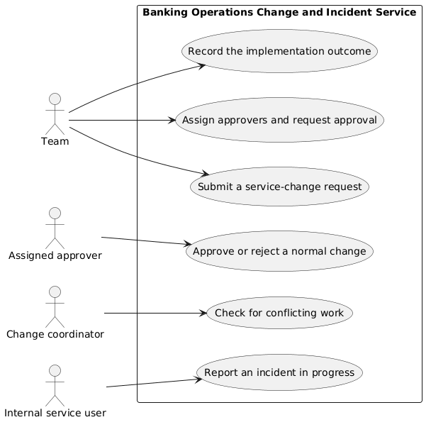
PlantUml:
https://github.com/TsubasaHMTU/ca1-analysis/blob/main/ca1-analysis/diagrams/use-case-model.puml

Detailed Use-Case Specification
UC03 Approve or reject a normal change
SCOPE: Banking Operations Change and Incident Service
Level: User goal
Primary actor: Assigned approver
Stakeholders and interests:
- Team: a recorded approval or rejection so implementation can proceed or stop
- Change Coordinator: visibility of the approval decision before conflicting work is checked
- Service owner: protection of the business service from an unsafe change
- Operation analyst/support: an operational view of the approved plan and any conditions
- Technical lead/owner: clarity of technical risk, rollback, and validation before implementation
Preconditions:
- A normal service-change request is submitted.
- Approvers are assigned.
Postconditions:
- Success guarantee: A service-change request is approved, recorded and assigned to an implementation window.
- Minimal guarantee: A service-change request is recorded as “Rejected”.
Trigger: The assigned approver begins reviewing a normal change that is waiting for approval.
Main success scenario:
- The Assigned approver reviews the complete request submitted by the Team.
- The Assigned approver approves the request.
- The System changes the request status to Approved.
- The System assigns the request to an implementation window.
- The System notifies the Team of the approval.
Extensions:
- The Assigned approver rejects the request.
  - The System changes the request status to Rejected.
  - The System notifies the Team of the rejection.
  - The use case ends.
- The person attempting to review the request is not the assigned approver.
  - The System notifies that the person is not an approver for that request.
  - The use case ends.

Behavioral Scenarios (Gherkin References)
https://github.com/TsubasaHMTU/ca1-analysis/blob/main/ca1-analysis/features/approve-normal-change.feature

Candidate Concepts and Domain Vocabulary

Concept Extraction and Decisions
https://github.com/TsubasaHMTU/ca1-analysis/blob/main/ca1-analysis/decisions/concept-extraction.docx

Domain Glossary
https://github.com/TsubasaHMTU/ca1-analysis/blob/main/ca1-analysis/decisions/domain-glossary.docx

Conceptual Domain Model

Conceptual Domain Model Diagram
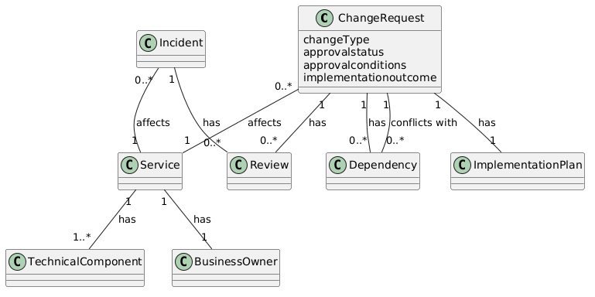
PlantUml:
https://github.com/TsubasaHMTU/ca1-analysis/blob/main/ca1-analysis/diagrams/domain-model.puml

Modelling Rationale
Why these classes were kept:
Classes were kept where they are central to the scenario around Change request. Terms that also appear in the functional requirements and business rules, especially those that recur often, were retained as conceptual classes.
Why some candidates were merged:
Candidates in a containment relationship were merged. For example, change record was merged into Change request because it is part of the same ongoing sequence for that request.
Why some candidates became attributes:
Where the scenario clearly fixes a limited set of values, the term was modelled as an attribute. Examples are Change type and Approval status.
Why these association names and multiplicities were chosen:
Association names and multiplicities follow stated rules and requirements. For example, RULE4 states that each service has one or more technical components, so Service is linked to technical component with multiplicity 1..*. Other links were chosen on the same basis.

Traceability Matrix
https://github.com/TsubasaHMTU/ca1-analysis/blob/main/ca1-analysis/decisions/traceability-matrix.docx

Reflection and AI Declaration
Decisions:
- Technical lead and technical owner were treated as one role, and Operations analyst and operational support were treated as one role.
- It was assumed that, for a normal change request, the requester designates the approvers.
- UC03 was selected as the detailed use case.
Revisions:
- The wording of the minimal guarantee was revised.
- The associations in the domain model were revised.
- The links in the traceability matrix were revised.
Limitations:
- The scenario is short, so the relationships among stakeholders remained unclear in places.
- It was not possible to define when an urgent change may proceed, or who may authorise an exception.
Unresolved questions:
See clarification questions Q1–Q5
AI Declaration:
- AI was used for English translation, review and critique, questions about structure, and locating relevant passages in the course references. When AI was used, the following skill was applied, and care was taken not to accept suggestions outside that purpose:
https://github.com/TsubasaHMTU/ca1-analysis/blob/main/ca1-analysis/references/SKILL_EN.md
- AI was not used to generate the requirements catalogue, or to create the use-case diagram or domain model from scratch.
- Example of an AI suggestion
https://github.com/TsubasaHMTU/ca1-analysis/blob/main/ca1-analysis/references/ai-example-01-ch8-candidate-classification-review.md
https://github.com/TsubasaHMTU/ca1-analysis/blob/main/ca1-analysis/references/ai-example-02-ch72-detailed-use-case-review.md

References
https://github.com/TsubasaHMTU/ca1-analysis/tree/main/ca1-analysis/references

Appendix

User stories
https://github.com/TsubasaHMTU/ca1-analysis/blob/main/ca1-analysis/requirements/user-stories.docx

